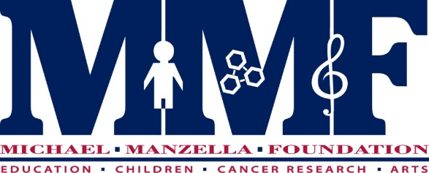

The Michael Manzella Fellowship for Summer, 2016

Supporting Projects in Cancer Research, Children’s Causes, and the Arts

Michael Manzella (Yale ’93) touched all the people he knew with his energy, talent, and willingness to give of himself. He was an accomplished musician and composer who, while at Yale, devoted himself to music and volunteered much of his time to the community by working with ill and underprivileged children. In 1993 he succumbed to a two-year struggle with cancer.
The Michael Manzella Foundation honors Michael’s legacy through its support of cancer research, children’s causes and the arts. The Summer Fellowship was designed to help a Yale student fulfill a summer project that captures in some way the spirit of Michael's life by expanding him or herself and reaching other individuals with his or her efforts. The Fellowship will be awarded to the freshman, sophomore, or junior in Yale College whose project’s goals best align with the mission of the Foundation to promote Cancer Research, Children’s Causes, and the Arts. While the Fellowship will support projects in the U.S. or abroad, preference will be given to projects undertaken in the U.S. Previous fellowship projects range from research in a cancer laboratory to social service work benefiting children to an arts project that enriches the community. Grant awards range from $1500 to $3500, to be used toward expenses (e.g., project supplies and/or lab fees, room/board, project-related travel expenses) according to the application budget.
A completed application must include:
- A resume (with name, cell and home phone numbers, email and mailing address)
- A proposed budget for the term of the project, including any sources of support (such as fellowships already received for the summer)
- A proposal that describes the summer project (500 words or less), including its current and potential benefit to others
- A personal statement that outlines the applicant's motivation and preparation for the proposed project (500 words or less)
- A Yale College transcript or copy of an unofficial academic record
- A letter of recommendation from someone who can evaluate the candidate and the feasibility and value of the proposed summer project.
- Items #1-5 must be submitted via email as a single PDF attachment by the deadline to Diana Loukedis Doherty, President, at managerfoundation@gmail.com.
- Item #6, the recommendation letter, should be sent via email directly from the recommending party to managerfoundation@gmail.com Questions regarding the fellowship may be directed to Diana Loukedis Doherty via email.
Deadline: March 15th, 2016 sent via email as PDF document
Selected candidates may be interviewed. Please include your email address with application, as notification for interviews may occur via email during Spring Vacation. Fellowship recipients will be notified by early April. Reporting requirements include a written mid-summer report (500 words) indicating the progress of the project and a final oral report (10-15 minutes) to be delivered before the Foundation’s Board of Directors in Fall, 2016.

Learn more about the Foundation at www.themichaelmanzellafoundation.com

